Customize an Arc Shape

Define an arc shape look like below:
Note: H200 is dimension of sagittal length of Arc. K600 is dimension of chord length of Arc.
Unit is metric.
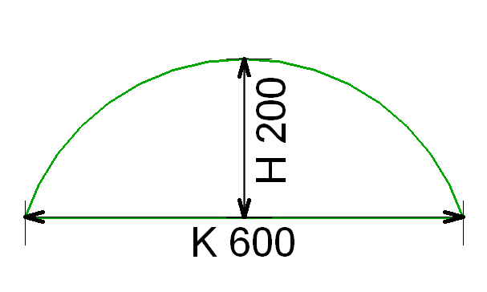

Step by step to define above Arc Shape:
1) Input “MyArc_2” in Name and select Arc.
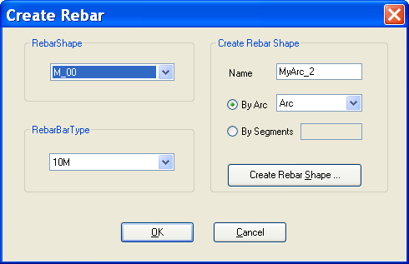

2) After above step, “Create RebarShape” will be presented as below:
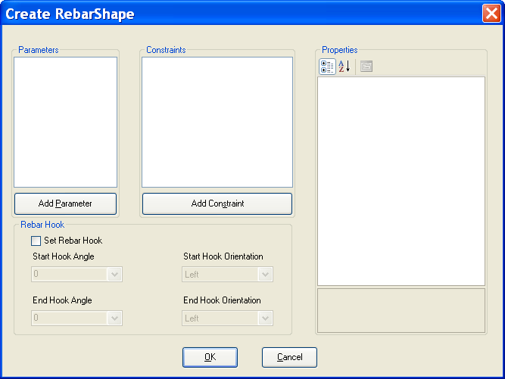

3) Add a double parameter K = 600.
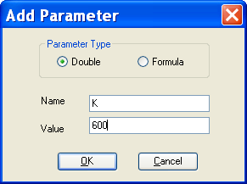

4) Add a double parameter H = 200.
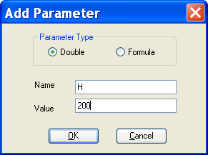

5) After adding two parameters K and H, the picture as below:
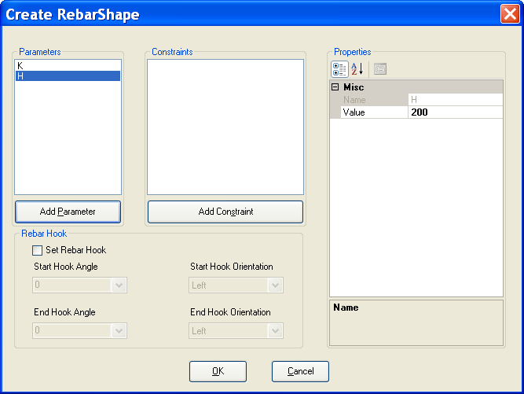
6) Add ConstraintChordLength and set its value as below:
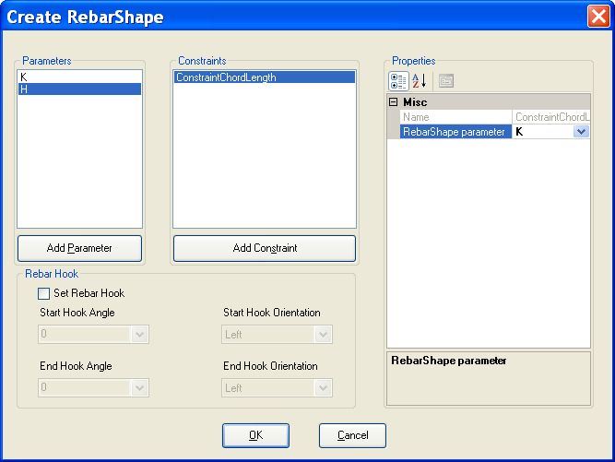

7) Add ConstraintSagittaLength and set its value as below:
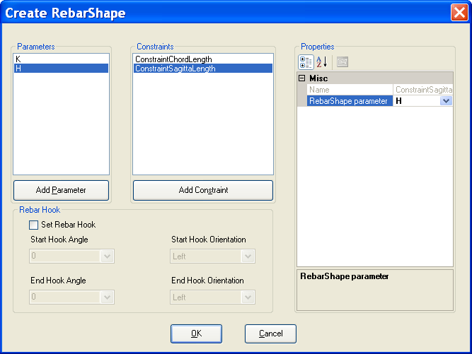

8) Check “Set Rebar Hook” and set hook angle and hook orientation as below:
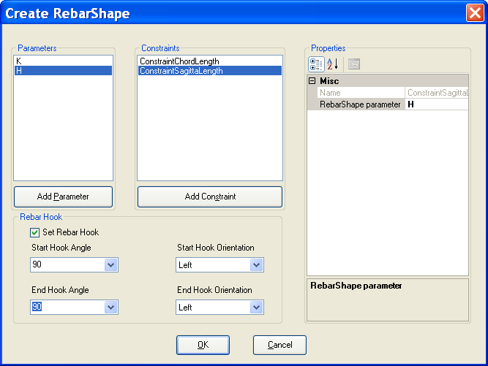

9) After all above steps, “MyArc_2” will be added to Revit document. It can be used to create Rebar.
